Chapter 14, Problem 89.

Obtain the magnitude plot of the response V_{o} in the network of Fig. 14.106 for the frequency interval 100 < f < 1000 Hz.

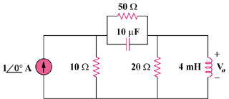

Figure 14.106
For Prob. 14.89.

